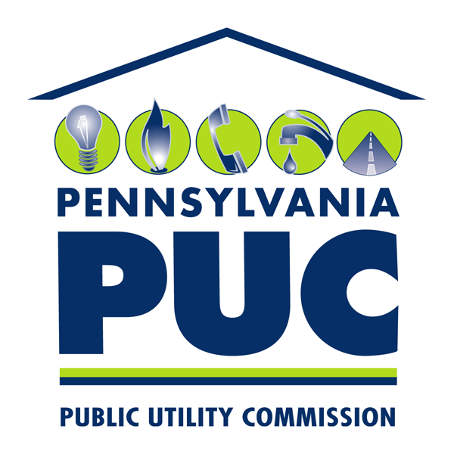 | COMMONWEALTH OF PENNSYLVANIA  PENNSYLVANIA PUBLIC UTILITY COMMISSION  P.O. BOX 3265, HARRISBURG, PA 17105-3265 | IN REPLY PLEASE REFER TO OUR FILE

March 22, 2011

Re: Great American Power, LLC
Pennsylvania Electric Generation Supplier Application
Docket No. A-2010-2205475

TO ALL PARTIES:

On November 20, 2010, Great American Power, LLC filed a letter Petition that was deemed an appeal from staff action pursuant to the Commission’s Regulations at 52 Pa. Code § 5.44. The subject of the letter Petition was Great American Power, LLC’s Application for an Electric Generation Supplier license then pending before the Commission. Through the letter Petition, Great American Power, LLC requested that the Commission expedite its consideration of that Application.

The record in this matter reveals that the Commission approved Great American Power, LLC’s Application for an Electric Generation Supplier license by Order entered on January 13, 2011, at this Docket. By virtue of that Order, Great American Power, LLC’s letter Petition has become moot and no further action by the Commission is necessary.
Sincerely,

Rosemary Chiavetta
Secretary

